Milestone :
- Only critical path milestones should be included.
- Overdue projected milestone dates should be marked as Red (please follow the CR process to change any baseline/planned dates).
- (Critical Path) Planned Dates that are under threat should marked as Amber.
- All overdue milestones must have projected dates in the future.

Key Risks:
- The “Target Date” is the date at which point the Risk will realise (aka “Trigger Date” on SharePoint).
- Risks must not have expired dates. Either the target date was unrealistic and therefore should be updated or the Risk should be closed and a relevant Issue raised.

Matters for Immediate Attention:
- The “Target Date” is the date at which point the Issue will impact the project plan, quality or budget (aka “Required Resolution” on SharePoint).
- Overdue target dates for Issues will be accepted but it will be assumed that appropriate escalation will be articulated in the General Comments and/or Executive Summary sections.

General:
- Please relate to Mo’s email on conciseness, clarity and recognising the audience. This includes avoiding Acronyms/Abbreviations to ensure appropriate Steering level summary.
- We will be reviewing any Risks or issues included against the SharePoint RAID logs (e.g. using the “zWorkstream Active High Impact” view).

Milestones
- List Key Milestones*, planned and projected dates. Apply RAG status to Projected Date. Change Request shall be applied for any Key Milestones that have missed Planned Date.
- Milestones should include any critical program / project-specific milestones plus current and next phase tracking milestones.
- List Milestones in chronological order based on Planned Date

Key Risks:
- The “Target Date” is the date at which point the Risk will realise (aka “Trigger Date” on SharePoint).
- Risks must not have expired dates. Either the target date was unrealistic and therefore should be updated or the Risk should be closed and a relevant Issue raised.

Matters for Immediate Attention:
- Report only key/critical issues and action being taken to resolve; includes issues that require escalation—i.e. immediate attention and assistance by leadership for resolution.
- The “Target Date” is the date at which point the Issue will impact the project plan, quality or budget (aka “Required Resolution” on SharePoint).
- Overdue target dates for Issues need to state the impact and the escalation taken in General Comments and/or Executive Summary section
General:
- Please relate to Mo’s email on conciseness, clarity and recognising the audience. This includes avoiding Acronyms/Abbreviations.

*Key Milestones
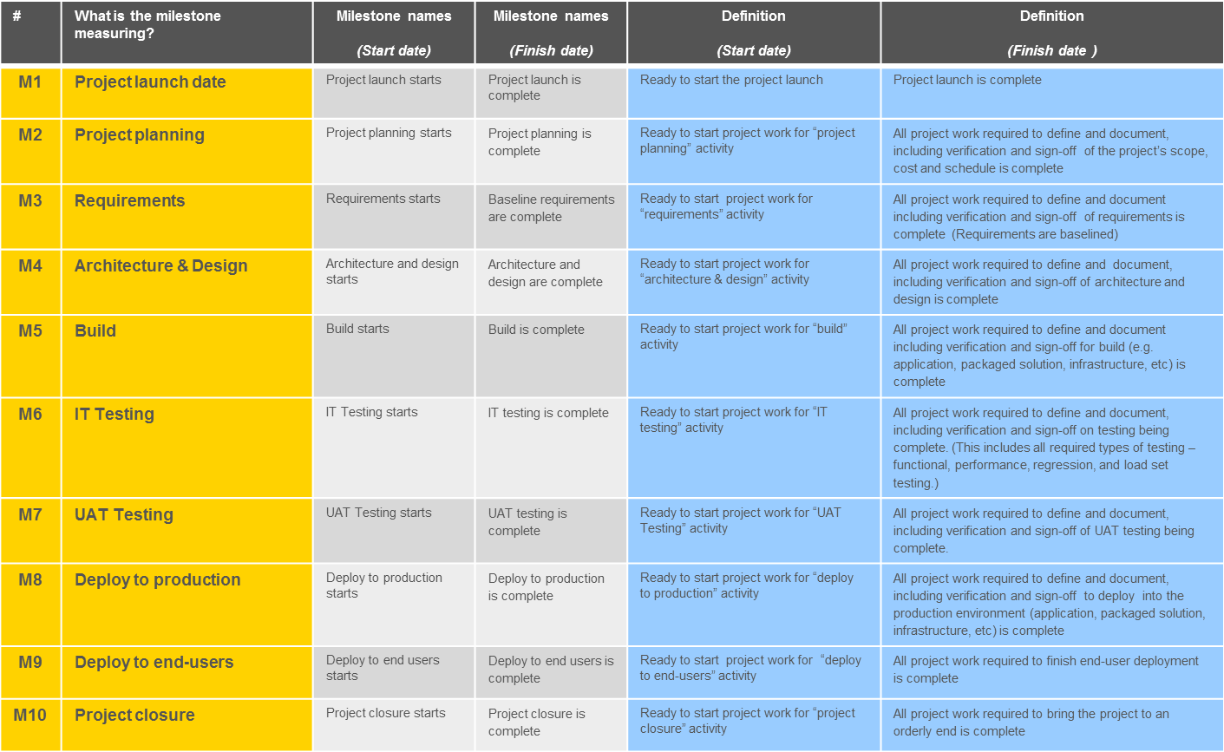

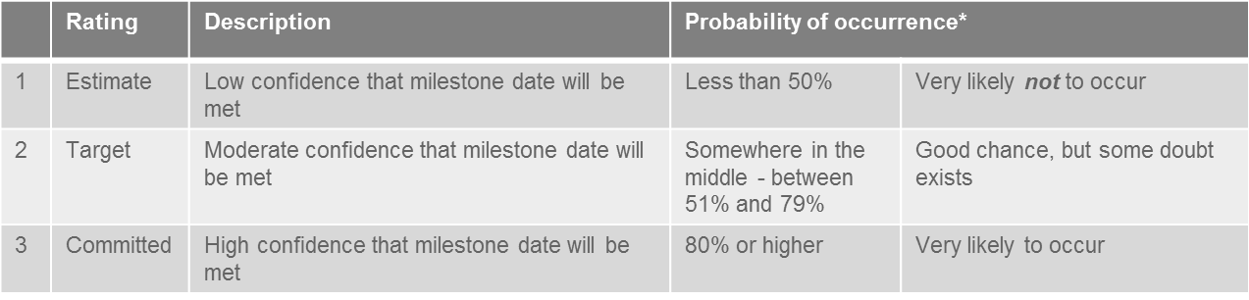
*Probability of occurrence is based on your experience and view as the PM, and not any scientific measure.

